Innovation in Election Administration – New Mexico Secretary of State
Clearie Award Submission

The New Mexico Secretary of State’s Office (SOS), along with the rest of the country, stands in post-election mode, reflecting back on its administration of the mid-term election, an election cycle commonly considered lightweight in comparison to presidential election years. The turnout for the 2018 general election in New Mexico, however, was noteworthy as 56% of the voters cast a ballot, an uptick of 16% from the previous mid-term election in 2014, which had roughly 40% voter participation.
Moreover, this election year marked the implementation of the new electronic ballot software system by which blind or visually impaired voters in New Mexico were able to cast an absentee ballot independently. The innovative ballot system was launched in the spring of 2018, just prior to the June primary election, and was extremely well-received by the blind community, as voters who had never truly been able to cast an absentee ballot independently were now afforded the means to do so. The implementation efforts for the electronic ballot system span over four years, with the concept largely stemming out of the statewide 2014 voting machine upgrade.
Throughout recent years, New Mexico voters’ accessibility to the ballot box has increased in many ways. From early voting, extended voting hours and locations, and consolidated polling locations where any voter can cast a ballot at any location, it has never been easier to participate in an election. In 2014, New Mexico election officials employed a new vote tabulation system across all counties, for the use in all elections. The tabulators, which far exceeded the capacity of the preceding make and model, not only furthered the reporting of vote results, they also came equipped with accessible voting functionality that made for a more independent voting experience for individuals with auditory, visual, physical or cognitive disabilities.
The disability community was grateful for the technology advances, however, the fact remained, that their voting options were still lacking in comparison to other voters. Anecdotal feedback received between 2014 through 2016 from voters and poll officials alike revealed a sense of intimidation to use the accessible voting technology at the polls for fear of delaying other voters, drawing attention to oneself, or because it seemed cumbersome. Complaints regarding unfamiliarity by poll officials and systematic malfunctions were also shared. The subsequent years were comprised of forging close relationships and collaboration between election administrators – specifically the previous and current Secretary of State Administrations - and the blind community, working to further enhance the accessible features of the tabulators.
In addition, the dialogue began focusing on absentee voting. Questions such as, “if all other voters are afforded the opportunity to independently and privately mark their ballot outside of the polling location for varying reasons, why can’t it be done for voters who use software on a daily basis to maneuver, read, and respond to other forms of written material?” were asked. Thus, in 2017, with the assistance of the National Federation of the Blind, the New Mexico Commission for the Blind, numerous state legislators, and the Secretary of State’s Office, the New Mexico legislature adopted legislation (House Bill 98) allowing for the electronic delivery of an absentee ballot to blind or visually impaired voters.

The July 1, 2017 effective date of House Bill 98 provided the SOS just a few short months to put the necessary components together to bring the new balloting method to fruition.
The short timeframe for implementation transpired thusly:
- November 2017 – April 2018: Adoption of an Administrative Rule, Absentee Voting 1.10.12 NMAC, contains protocol necessary for implementation (Link to rule making webpage http://www.sos.state.nm.us/Elections_Data/2018-absentee-voting-rulemaking.aspx)
- December 2017 – May 2018: Design and printing of ballot delivery packages distinguishable via tactile impression.
- January 2018 – May 2018: Software development of online absentee application, electronic ballot and integration with statewide voter registration system. (User interface screenshots below)

New Mexico is the second state in the union, after Maryland, to implement an innovative voting method of this type for blind and visually impaired electors. In 2015, election officials from both states entered into a memorandum of understanding (MOU), which granted a copy of the Maryland online ballot delivery system source code to New Mexico at no charge. However, after an in-house assessment, it was ultimately decided that the complete code and architecture for the new balloting method would be developed outright by internal SOS IT staff, as New Mexico’s process adopts unique procedures that the Maryland system does not include.

In order to approximate a private and independent absentee voting experience New Mexico’s system includes functionality allowing blind and visually impaired voters to mark, print, and mail a hard copy of their ballot back to the county clerk for processing – all independently. (This is discussed further below).

The Online Absentee Ballot can be requested on the SOS website at www.nmvote.org. The system is designed so that any voter can request an absentee ballot online, however, blind or visually impaired voters have exclusive access to request an accessible ballot. The voter must provide their state-issued identification number, date-of-birth, and Social Security Number and execute a certificate affirming blindness/visual impairment, and therefore eligibility, to the accessible ballot delivery and marking feature. The voter’s personal identifying information is verified against their Motor Vehicle Department record and, if valid, funneled to the state’s electronic voter registration and information system (SERVIS).

The application will be visible to the appropriate County Clerk, dependent upon the voter’s residential address, who will then process the application. The voter’s record is then flagged for an absentee ballot, specific to their voting precinct, and will be queued for delivery to the email address provided by the voter. Here is a preview of the online experience:
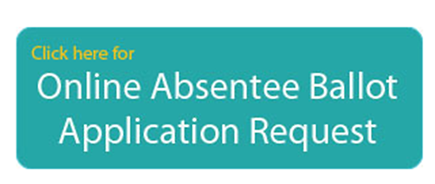 | 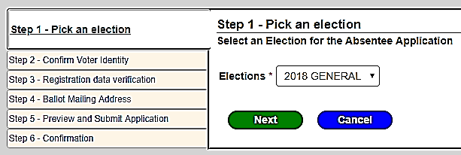
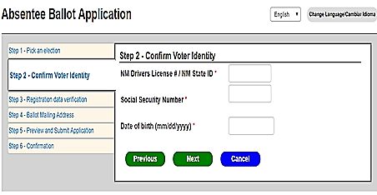
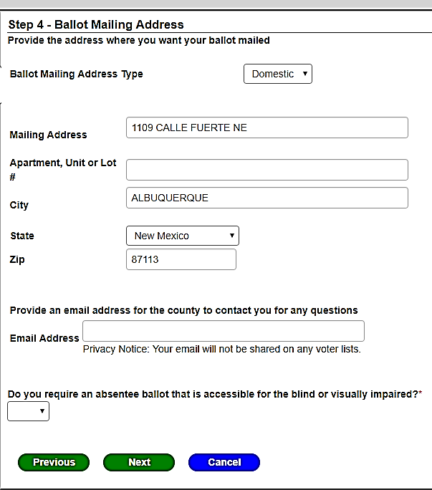
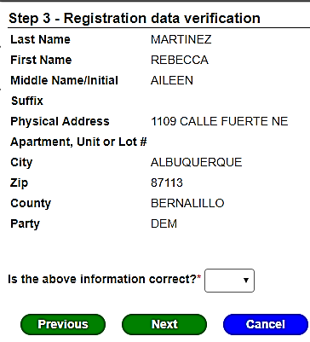

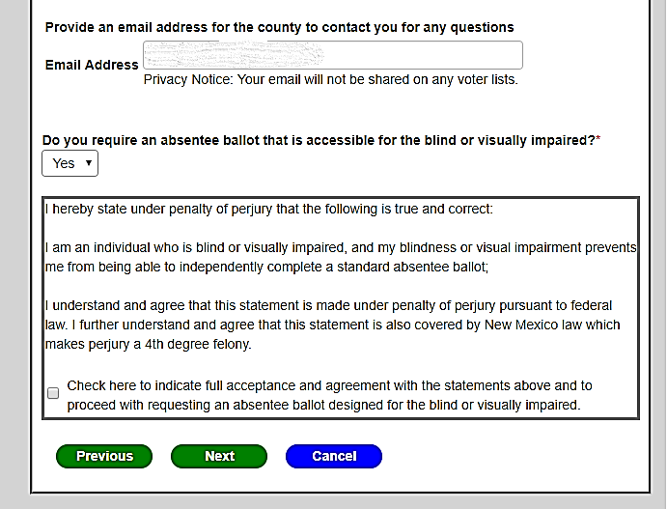
Immediately after the absentee application has been submitted, the voter will receive an email when their application is accepted by the county with a link to access the ballot marking tool and an absentee ballot will be emailed to the voter within 24 hours of the approval of their application. In order for the ballot to be accessed, the voter must enter the same personal identification information provided upon application. This authentication process also includes the verification of a distinctive character string issued to the specific voter upon application. The combination of the character string, along with the personal identification information, must match in order for the voter to access the ballot. This measure provides added security measures by safe guarding against unauthorized foreign actors. The image below contains a screenshot of the voter interface when accessing the emailed ballot. Please note that each screen is audible translated through the use of the voter’s nonvisual or low vision access technology.
The successful implementation of this new voting method was revealed to the blind and visually impaired community at the New Mexico Chapter of the National Federation of the Blind annual meeting in Albuquerque on April 21, 2018. The new process was met with great appreciation, culminating in the presentation of both a proclamation of gratitude and the giving of the Albert Gonzales Distinguished Public Servant award, presented to Secretary of State Maggie Toulouse Oliver, for her office’s work in bringing the absentee ballot application to fruition.
Due to the close date of the process’s implementation to the June 5, 2018 Primary Election, 18 blind or visually impaired voters used the option. However, for the November 6, 2018 General Election, 64 voters took advantage of the option.
The New Mexico Secretary of State’s office is very pleased with the successful implementation of such a crucial ballot access feature, providing increased independence in voting to the blind and visually impaired community in New Mexico. The partnerships forged with both the National Federation of the Blind – New Mexico and the New Mexico Commission for the Blind have enriched the work of the Secretary of State’s Office and have provided for a more accessible election process in New Mexico.

Just one business day after an absentee ballot is emailed, an official absentee ballot return package will be mailed out to the voter. This package is sent in an outer envelope containing an embossment such that the blind or visually impaired voter can identify this election-specific mail by touch, a requirement established within the Administrative Rule adopted by the Secretary of State’s Office in April, 2018, “The secretary of state shall prescribe an official transmittal envelope such that the blind or visually impaired voter can distinguish it for the purposes of returning the absentee ballot. “ (NMAC 1.10.12).

The accessible ballot lists each ballot question or race and relevant declared candidate(s) for that contest on the screen so that the voter can navigate, listen to an audio transcription of the content, and mark their vote selections one at a time. Once the voter finishes marking their selections they are presented with a preview of the entire ballot that includes their vote selections for their review. The voter has the option of going back to a particular contest or ballot question(s) should the need arise.

When the ballot is marked, it is to be printed by the voter’s home computer, along with an Oath of Registered Voter, which must be signed by the voter, attesting to their vote. The oath language is prescribed by law, however, in consultation with Commission for the Blind, and was designed to provide sufficient space for the voter’s signature to be placed without having to worry about signing within a confined or specific area on the form.

The printed ballot must be placed in an inner secrecy envelope and then into a larger return envelope, which also includes the voter’s signed oath. The ballot marking instructions provided to the voter are attached for your review.

The new application and process was announced to the public via press release on April 30, 2018, about one week before the last day to register to vote, and the first day to mail out absentee ballots in advance of the June 5 Primary Election. A public presentation was made to the annual meeting of the National Federation of the Blind – New Mexico Chapter (NFB-NM) in Albuquerque on April 21, and a full demonstration was given at the annual meeting on April 20, 2018.

The implementation of the new process was honored by the NFB-NM, who issued a resolution in support of the Secretary of State’s Office, as well as presenting the Albert Gonzales Distinguished Public Service award of recognition to Secretary of State Maggie Toulouse Oliver on this same day. The resolution, along with a few other statements of appreciation, are included.

Table 1 below illustrates the use of the electronic balloting system during its initial year. The use during the general election shows that nearly three times more voters cast a ballot using the accessible ballot, in contrast to the number of voters who used it during the primary election.

Table 1 - Usage of Ballot
 | # of Requests | # of ballots cast
2018 Primary Election | 20 | 18
2018 General Election | 105 | 64
*Data shows that a number of voters who requested an online ballot ultimately chose to cast a ballot in person.
Appendix

2017 New Mexico State Legislature, House Bill 98 (attached)
2018 Administrative Rule, Absentee Voting 1.10.12 NMAC (attached)
Secretary of State’s Office Ballot Instructions
National Federation of the Blind of New Mexico, Resolution 2018-01

A copy of the official House Bill 98 is attached.

