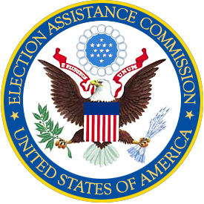
U. S. ELECTION ASSISTANCE COMMISSION
1225 New York Avenue, NW, Suite 1100
Washington, DC. 20005

MEMORANDUM

To: Chairman Davidson, Vice Chairman Rodriguez, and Commissioner Hillman

From: Commissioner Hunter

Date: December 18, 2007

Re: Proposed disclaimers for the National Mail Voter Registration Form

Website Disclaimer

The following disclaimer shall be posted in red on the Election Assistance Commission’s website in the section entitled Register to Vote – The National Voter Registration Act:

“As of December 18, 2007, the following states have requested a change to their state instructions: Arizona, Colorado, Delaware, Georgia, New Jersey, and Rhode Island. The Commission has not yet approved these requests.”

Procedure: The Director of Elections shall update on the website the list of states that have requested changes within 48 hours of the request coming to the attention of the EAC. The date shall also be updated.

State Instructions Disclaimer

The following disclaimer in italics shall be added below each state instruction in which the state has requested the Election Assistance Commission to change their state instruction and the Election Assistance Commission has not changed the instruction:

“The state of _____ has requested a change to its state instructions. The Election Assistance Commission has not approved this request.

