Setting up solution on TFS and Visual Studio
- Connect to TFS:
  - Open Visual Studio and go to Team Explorer:
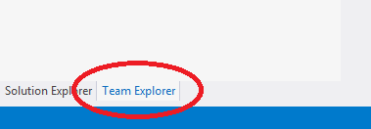
  - Connect to a team project:
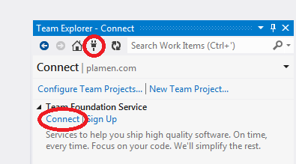
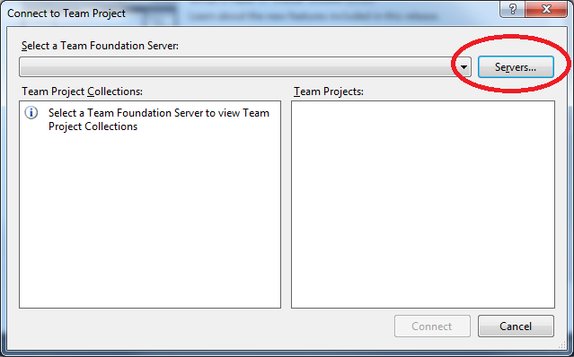
  - Register TFS server (if you don’t have permission submit ticket to servers):
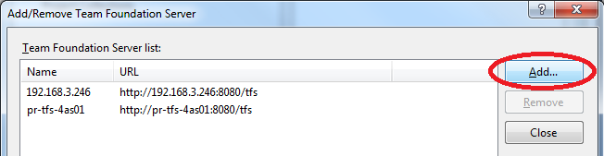
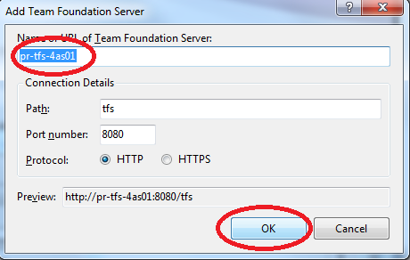
  - Select Collection and team project (if you don’t see your project submit ticket to servers – Your project will be called Yourname.com NOT training.com):
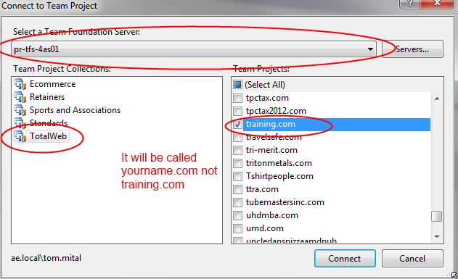
- Setup the solution locally:
  - Open Source Control Explorer:
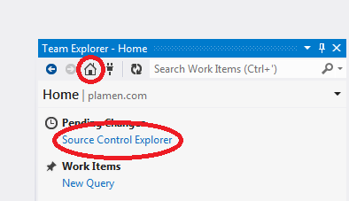
  - Map to local folder:
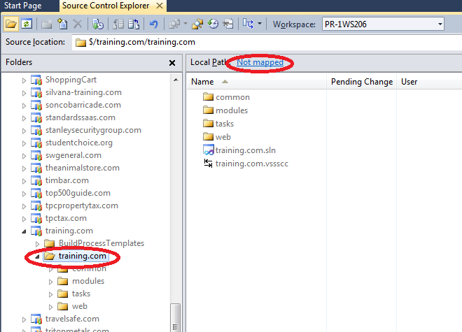
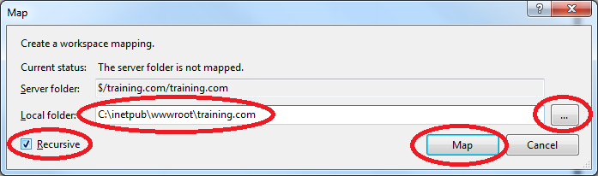
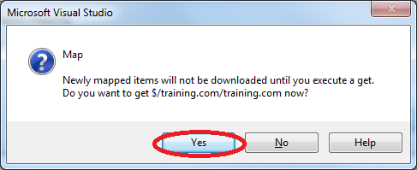
- Open solution is Visual Studio:
  - From Source Control Explorer double click on solution file:
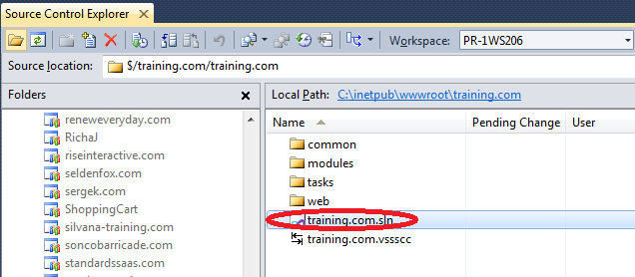
  - Build entire solution (is any compilation errors contact your Sr. Programmer)
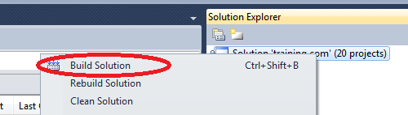
  - Optimize solution for faster builds:
Under solution explorer right click web > Property Pages:
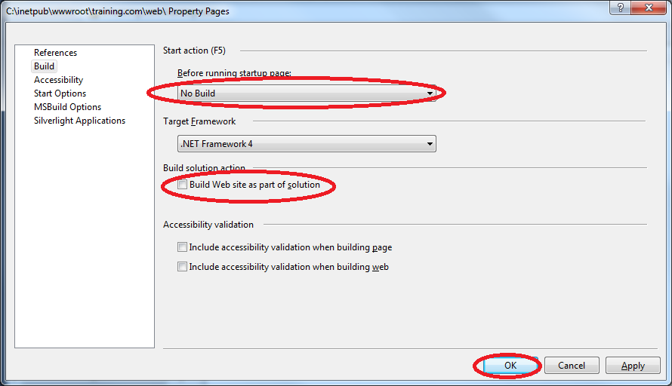
- Prep web.config:
  - Disable jobs by commenting out the section:
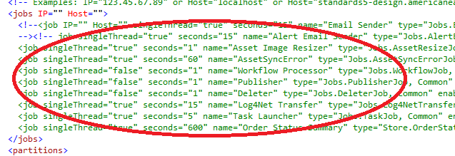
  - Update log4net error recipient to your email address:
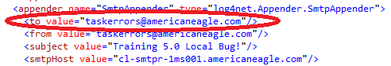
  - Verify connection strings and server paths (make sure everything points to your project):
    - MasterConnectionString
    - LoggerConnectionString
    - GlobalAdminUrl
    - GlobalRefererName
    - BaseWebsitePath
    - CKEditorFolder
    - SoftErrorMapFile
    - AssetsFolder
    - ArchiveAssetsFolder
    - AssetServerUrl
    - SecureAssetServerUrl
    - IsRunningLocal = “True”
  - Update base urls:
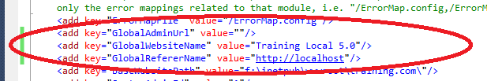
- Setup IIS Express:
  - Right click the web project and select ‘Properties’.
  - Set the start options similar to those below. Ensure all the ‘Debuggers’ items are unchecked, and that the command line argument is a value specific to your project (keep this value noted for a later step)

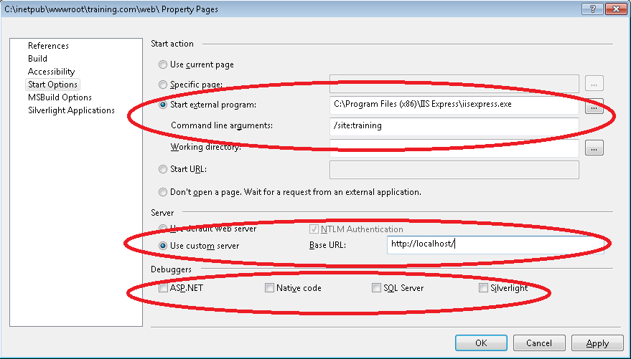

  - Run the IIS Express icon your desktop for the first time. Once loaded, select the ‘Q’ option to end the process. This will have created the initial configuration files, which you can find inside the C:\Users\<your_login>\Documents\IISExpress\config\ folder
  - Open the C:\users\<your_login>\Documents\IISExpress\config\applicationhost.config and find the element <sites> in that file. Inside that elements you should see one site configured there by default with the name=”Website1”. Paste this code right below it:
<site name="yourname-training" id="1">
<application path="/">
<virtualDirectory path="/" physicalPath="C:\inetpub\wwwroot\yourname-training.com\web\" />
<virtualDirectory path="/cms" physicalPath="\\cl-cgc-4wb01\wwwroot\yourname-training.com\cms" />
<virtualDirectory path="/assets" physicalPath="\\cl-cgc-4wb01\wwwroot\yourname-training.com\assets\" />
<virtualDirectory path="/ckeditor" physicalPath="\\cl-cgc-4wb01\wwwroot\yourname-training.com\CKEditor\" />
</application>
<bindings>
<binding protocol="http" bindingInformation="*:80:localhost" />
</bindings>
<applicationDefaults applicationPool="Clr4IntegratedAppPool" />
</site>
- To run the solution you can run this command “C:\Program Files (x86)\IIS Express\iisexpress.exe /siteid1” through command line or create a shortcut as in the image below for each solution for ease of access when swapping between running multiple solutions:
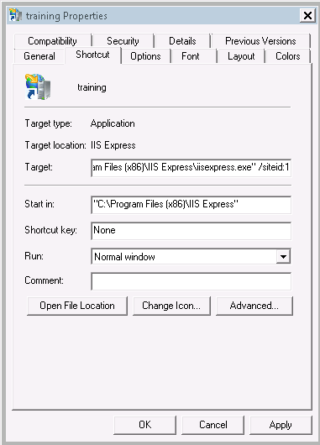

If you use Skype, be sure to turn off ‘Use port 80 and 443 as alternatives for incoming connections’:
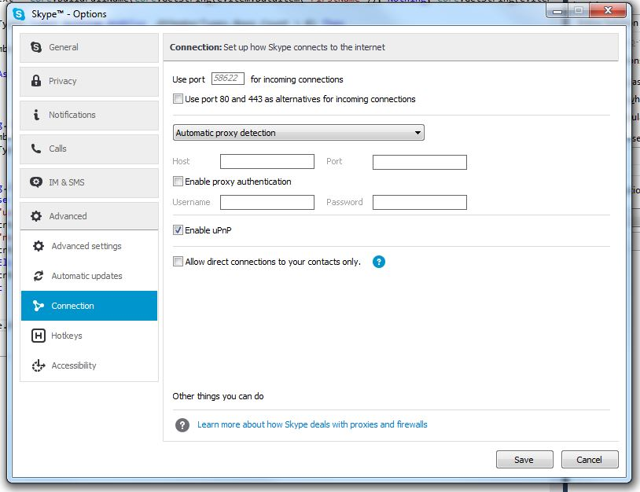

- You should always have IISExpress running in the background against your solution. This command window should remain open until you are ready to swap to another solution or stop running the current:
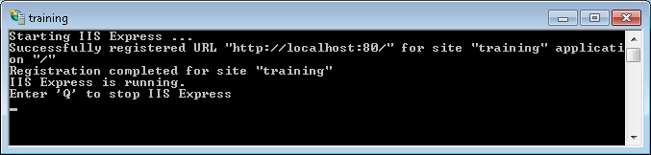
- Navigate to http://localhost/ and http://localhost/admin/ to access your website locally. No need to start the debugger.
- To debug hit Debug from the menu > Attach to process… > select IISExpress.exe
